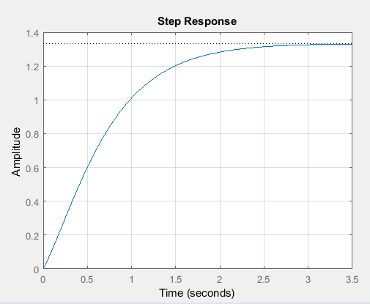**Exercise 1(a)**

A = [0 1; -6 -5];

B = [0; 1];

C =[8 1];

D =[0];

[num,den] = ss2tf(A,B,C,D);

sys =tf(num,den);

step(sys);

grid on;

**Exercise 1(b)**

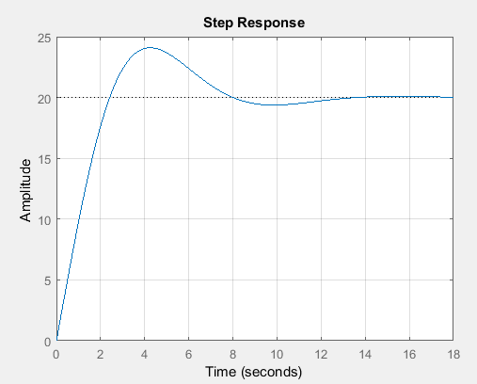

A = [0 1 0;0 0 1;-1 -2 -3];

B = [10;0;0];

C =[1 0 0];

D =[0];

[num,den] = ss2tf(A,B,C,D);

sys =tf(num,den);

step(sys);

grid on;

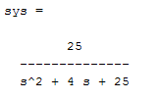**Exercise 2**

num =[0 0 25];

den =[1 4 25];

sys = tf(num ,den)

**Exercise 3**

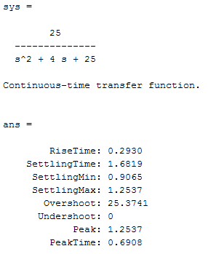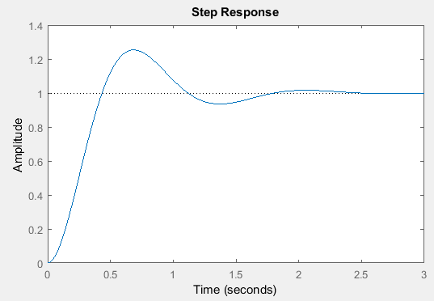

num =[0 0 25];

den =[1 4 25];

sys = tf(num ,den)

ltiview(sys)

stepinfo(sys)

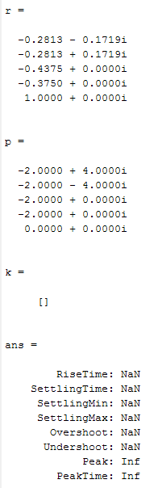**Exercise 4**

num =[3 25 72 80];

den =[1 8 40 96 80 0];

t = 0:0.01:10;

sys = tf(num ,den)

c_t = step(sys,t)

plot(t,c_t)

[r,p,k]=residue(num,den)

ltiview(sys)

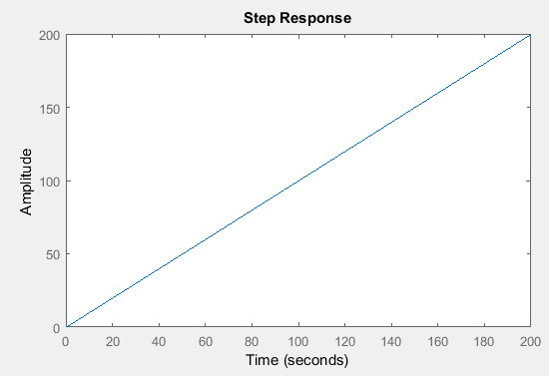stepinfo(sys)

**Exercise 5**

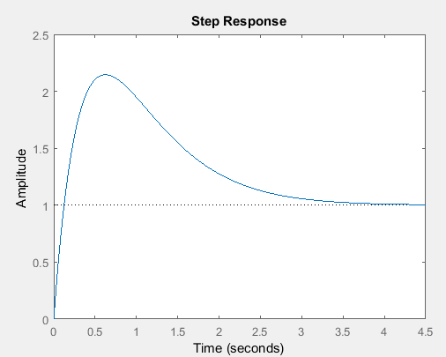num =[0 10 4];

den =[1 4 4];

sys = tf(num ,den)

figure;

step(sys)

title('Step Response')

num2 =[0 10 4];

den2 =[1 4 4 0];

sys2 = tf(num2 ,den2)

figure;

step(sys2)

title('Ramp Response')

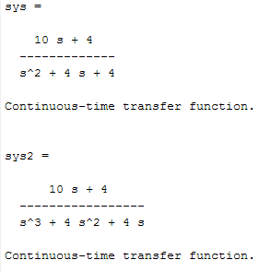

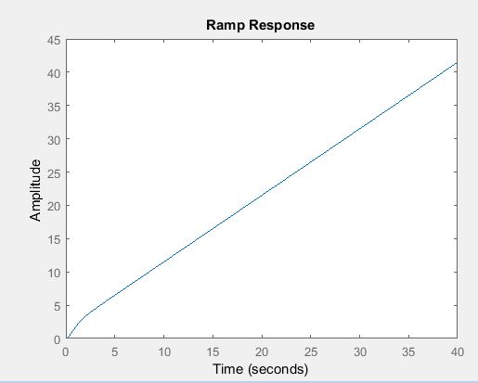

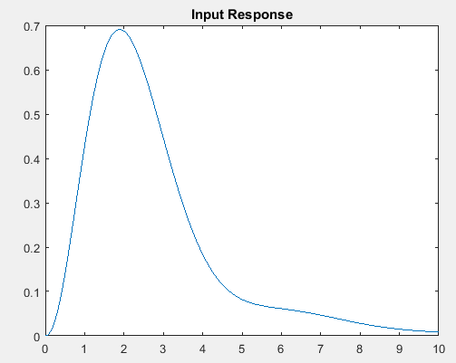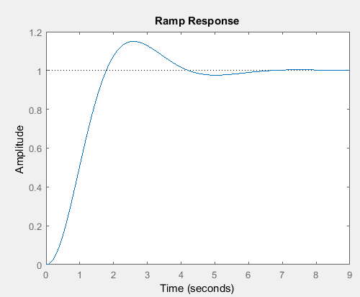**Exercise 6**

num =[0 1 10];

den =[1 6 9 10];

sys = tf(num ,den)

figure;

step(sys)

title('Ramp Response')

t = 0:0.01:10;

r_t=exp(-0.5*t);

y=lsim(sys,r_t,t);

figure;

plot(t,y)

title('Input Response')

**Exercise 7**

num =[0 0 16];

den =[1 4 16];

sys = tf(num ,den)

step(sys,t)

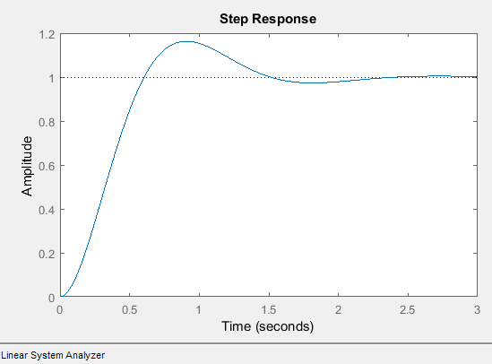ltiview(sys)

stepinfo(sys)

